Below source ids having same structure of websites

|  |  |
| --- | --- |
| Source id | BASED URL |
| 77106699 | https://www.jstage.jst.go.jp/browse/geochemj/list/-char/en |
| 77131899 | https://www.jstage.jst.go.jp/browse/jcej/list/-char/en |
| 77157399 | https://www.jstage.jst.go.jp/browse/koron/list/-char/en |
| 77457099 | https://www.jstage.jst.go.jp/browse/jtappij/list/-char/en |
| 77457499 | https://www.jstage.jst.go.jp/browse/jlwa/list/-char/en |
| 77479999 | https://www.jstage.jst.go.jp/browse/jinstmet/list/-char/en |
| 77480099 | https://www.jstage.jst.go.jp/browse/jcersj2/list/-char/en |
| 77566999 | https://www.jstage.jst.go.jp/browse/jjspe/list/-char/en |
| 77603599 | https://www.jstage.jst.go.jp/browse/jjws/list/-char/en |
| 77631299 | https://www.jstage.jst.go.jp/browse/transcom/list/-char/en |
| 77631399 | https://www.jstage.jst.go.jp/browse/transele/E97.C/2/_contents/-char/en |
| 77631499 | https://www.jstage.jst.go.jp/browse/transfun/list/-char/en |
| 77631599 | https://www.jstage.jst.go.jp/browse/transinf/list/-char/en |
| 77638699 | https://www.jstage.jst.go.jp/browse/jjspm/list/-char/en |

Go to the Base URL then landing page will appear like below

* Select the issue from the issue list.

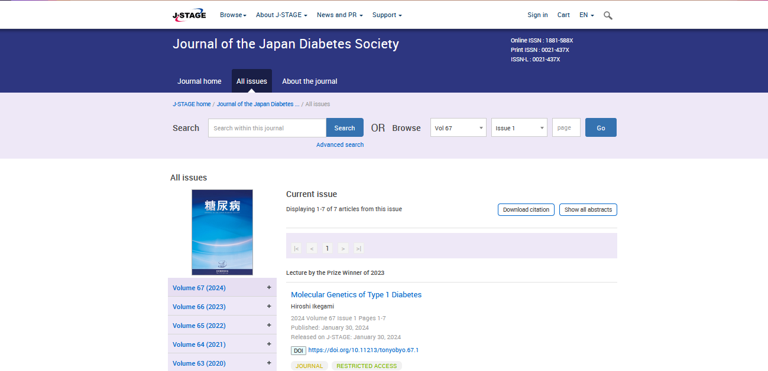

**Select the Current issue from here.**

* **All required articles will be listed here.**

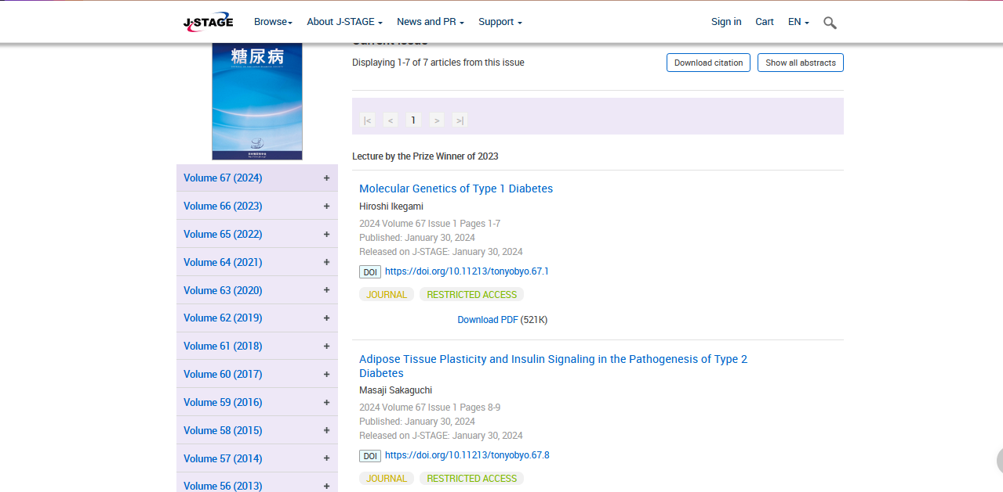

* **Meta data can be captured as below.**

**Volume, issue and Year, PAGE RANGE**

* **Click the article name to open the article information page to download the PDF.**

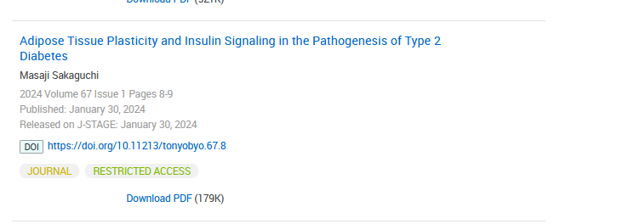

**Article name**

**DOI (start with 10)**

**Click the download link to download the PDF.**

**Page Range**